**Rajasthan**

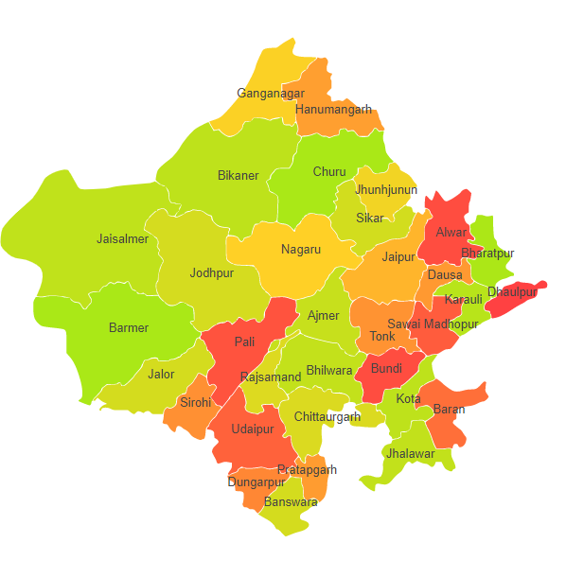

Rajasthan comprises of two Agro Ecological Regions (AER) 2,4 & 5.

**Agro-Eco Region 2:** AER 2 in Rajasthan comprises of Barmer, Bikaner, Churu, Ganganagar, Hanumangarh, Jaiselmer, Jalor, Jhunjhunun, Jodhpur, Nagpur, Pali, Sikar and Sirohi districts of Western Plain under Agro Ecological Sub Regions (AESR) 2.1 & 2.3.

**Agro-Eco Region 4:** AER 4 in Rajasthan comprises of Alwar, Ajmer, Bharatpur, Bhilwara, Bundi, Chittaurgarh, Dausa, Dholpur, Dungarpur, Jaipur, Karauli, Rajsmand, Swaimadhopur, Tonk and Udaipur districts of Northern Plain and Central Highlands including Aravallis under Agro Ecological Sub Regions (AESR) 4.1 & 4.2.

**Agro-Eco Region 5:** AER 5 in Rajasthan comprises of Banswara, Baran, Bundi, Chittaurgarh, Jhalawar, Kota and Pratapgarh districts of Central (Malwa) Highlands under Agro Ecological Sub Region (AESR) 5.2.